BACK INJURY PREVENTION & ERGONOMICS PLANNING DOCUMENT

Ergo Zone Toolkit


SCOPE AND APPLICATION

This procedure applies to operations where personnel perform manual lifting and have the potential for material handling and ergonomic stresses.

The purpose of this procedure is to prevent back injuries and Work-Related Muscular Skeletal Disorders (WMSDs) or cumulative trauma injuries to personnel.

IMPLEMENTATION
Implementation of this program is the responsibility of the [Enter Position]

PROCEDURE

Safe Lifting Practices Management
- Evaluate all assignments to assess if it can be completed without risk of back injury (e.g., moving boxes, computers, equipment, etc.).
- Require that heavier items are stored on lower shelving units; ideally below knee and shoulder height.
- Recognize lifting-intensive tasks (poor lift design, high frequency, and/or excessive weight), and provide the means by which personnel can perform lifting duties without risk of injury, e.g. carts, dollies, trucks with lift gates.
- Secure outside assistance if personnel cannot safely accomplish the job (e.g., additional staff, contract movers).
- Contact the [Enter Position] when assistance is necessary to evaluate a lifting task that may pose a back injury risk to assigned personnel.
- Ensure that personnel receives the required training outlined below.

Training Management
- Require that personnel who may have lifting as part of their duties receive training that includes the following topics:
- Recognizing potential hazards and how to correct and prevent them.
- Proper workstation setup and maintenance.
- How to avoid unnecessary physical stress and strain.
- How to comfortably handle lifting jobs without undue strain.
- Proper use of equipment.
- Stretching and strengthening exercises to minimize the risk of injury.
- Complete training before an employee is assigned to a task that involves lifting.
- Documents all training in the Training Track application of the Risk Management Center.

Office Moves and Relocations
- Utilize professional movers for moving office furniture for both offsite moves and interoffice moves.
- Desks, file cabinets, bookcases, etc.
- Intensive moving of file boxes
- Any other heavy equipment or materials.
- Ensure that the moving contractor is appropriately evaluated and insured.
- Assure as applicable that all unstable items (e.g., bookcases) are secured to prevent tip over in transit, and when placed.

Workplace Evaluations
- Complete at all workstations.
- Determine if stresses exist and what prevention injury controls will need to be put in place.
- Use the forms at the end of this procedure.
- Do the “Caution Job Assessment” first.
- Complete a “Risk Factor Assessment” for any “Caution Zone Task” that is identified.
  - “Risk Factor Assessments” are used to determine specific causal factors and to work on designing these away.

Medical Management
- Ensures that all employees, existing and prospective, are properly placed based on the demands of a job and the capacities of the individual.
- Employees with reported cumulative trauma or work-related muscular skeletal disorders (WMSDs) are provided with the following:
- Access to prompt and effective medical evaluation, treatment and follow-up.
- Work task assessments to identify any stresses and possible corrective actions.
- Work restrictions recommended by the medical provider.

Documentation Requirements
The following documents are to be retained in the applicable sections of the Risk Management Center:
- Summary of the trainings, and training materials for all staff.
- Completed Caution Job and Risk Factor Assessments.

The Risk Management Center is to be used to document all information including the following:

DOCUMENTS | RISK MANAGEMENT CENTER LOCATION
Written Back Injury Prevention and Ergonomics Evaluation Program | My ContentTM
Training Documentation including:  - Classroom training and training course completed  - Sign-in sheets  - Quizzes  - Skills evaluations  - Operator Certificates | Training TrackTM application
Pre-shift Inspection Checklists | My ContentTM
Safety Observations | Job Hazard Analysis/ Safety Observation ToolTM
Near misses | Incident TrackTM
Accidents and claims | Incident TrackTM
Supplier and manufacturer Certificates of Insurance | COI TrackTM
Safety Data Sheets | SDS TrackTM

APPENDIX A | COMPUTER WORKSTATION CHECKLIST
Work Area _________________ Date ________ Conducted By ______________ Reviewed By ________________
COMPUTER WORKSTATION CHECKLIST | YES | NO
- Does the workstation ensure proper worker posture, such as:
Horizontal thighs?
Vertical lower legs?
Feet flat on floor or footrest?
Neutral wrists?
- Does the chair:
Adjust easily?
Have a padded seat with a rounded front?
Have an adjustable backrest?
Provide lumbar support?
Have casters?
- Are the height and tilt of the work surface on which the keyboard is located adjustable?
- Is the keyboard detachable and adjustable?
- Do keying actions require minimal force?
- Is there an adjustable document holder?
- Are armrests provided where needed?
- Are glare and reflections avoided?
- Does the monitor have brightness and contrast controls?
- Do the operators judge the distance between eyes and work to be satisfactory for their viewing needs?
- Is there sufficient space for knees and feet?
- Can the workstation be used for either right- or left-handed activity?
- Are adequate rest breaks provided for task demands?
- Are high stroke rates avoided by
Job rotation?
Self-pacing?
Adjusting the job to the skill of the worker?
- Are employees trained in
Proper postures?
Proper work methods?
When and how to adjust their workstations?
How to seek assistance for their concerns?
- Do operators use computer workstations for more than 4 hours a day?
- Environment
Is the temperature too hot or too cold?
Are the worker's hands exposed to temperatures less than 70 degrees Fahrenheit?
Is the workplace overly or poorly lit?
Is there excessive noise that is annoying, distracting, or producing hearing loss?
Is there upper extremity or whole body vibration?
Is air circulation too high or too low?

CAUTION ZONE CHECKLIST Use one sheet for each position evaluated.
Movements or postures that are a regular and foreseeable part of the job, occurring more than one day per week, and more frequently than one week per year. |  | If done in this job position    the box |  | Job Position evaluated:  Date: | No. of employees in these jobs?
AWKWARD POSTURE |  |  |  | COMMENTS/OBSERVATIONS
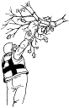 | - Working with the hand(s) above the head, or the elbow(s) above the shoulders more than 2 hours total per day.
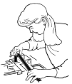 | - Working with the neck or back bent more than 30 degrees (without support and without the ability to vary posture) more than 2 hours total per day.
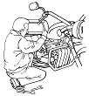 | - Squatting more than 2 hours total per day.
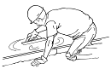 | - Kneeling more than 2 hours total per day.
APPENDIX B | CAUTION ZONE CHECKLIST

HIGH HAND FORCE |  |  |  | COMMENTS/OBSERVATIONS
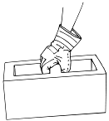 | - Pinching an unsupported object(s) weighing 2 or more pounds per hand, or pinching with a force of 4 or more pounds per hand, more than 2 hours per day (comparable to pinching half a ream of paper).
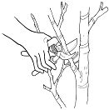 | - Gripping an unsupported object(s) weighing 10 or more pounds per hand, or gripping with a force of 10 or more pounds per hand, more than 2 hours total per day (comparable to clamping light duty automotive jumper cables onto a battery).
HIGHLY REPETITIVE MOTION |  |  |  | COMMENTS/OBSERVATIONS
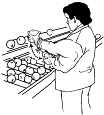 | - Repeating the same motion with the neck, shoulders, elbows, wrists, or hands (excluding keying activities) with little or no variation every few seconds, more than 2 hours total per day.
 | - Performing intensive keying more than 4 hours total per day.
REPEATED IMPACT |  |  |  | COMMENTS/OBSERVATIONS
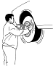 | - Using the hand (heel/base of palm) or knee as a hammer more than 10 times per hour, more than 2 hours total per day.

HEAVY, FREQUENT OR AWKWARD LIFTING  (A simple scale can be used to determine the weight of materials) |  |  | COMMENTS/OBSERVATIONS
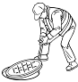 | - Lifting an object weighing more than 75 pounds once per day or more than 55 pounds more than 10 times per day.
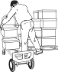 | - Lifting objects weighing more than 10 pounds if done more than twice per minute, more than 2 hours total per day.
 | - Lifting objects weighing more than 25 pounds above the shoulders, below the knees or at arm's-length more than 25 times per day.
MODERATE TO HIGH HAND- ARM VIBRATION  (Closely estimate or obtain the vibration value of the tool in use) |  |  | COMMENTS/OBSERVATIONS
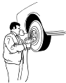 | - Using impact wrenches, carpet strippers, chain saws, percussive tools (jackhammers, scalers, riveting or chipping hammers) or other tools that typically have high vibration levels, more than 30 minutes total per day.
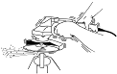 | - Using grinders, sanders, jigsaws or other hand tools that typically have moderate vibration levels more than 2 hours total per day.

APPENDIX C | HAZARD ZONE CHECKLIST

HAZARD ZONE CHECKLIST
For each "Caution Zone Job" find any physical risk factors that apply. If a hazard exists, it must be reduced below the hazard level or to the degree technologically and economically feasible.
Movements or postures that are a regular and foreseeable part of the job, occurring more than one day per week, and more frequently than one week per year. |  | Job Position evaluated:  Date: |  |  | No. of employees in these jobs?
AWKWARD POSTURE |  |   HAZARD EXISTS |  | COMMENTS/OBSERVATIONS
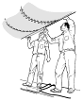 | - Working with the hand(s) above the head, or the elbow(s) above the shoulders | More than 4 hours total per day
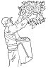 | - Repeatedly raising the hand(s) above the head, or the elbow above the shoulder more than once per minute | More than 4 hours total per day
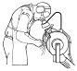 | - Working with the neck bent more than 45° (without support or the ability to vary posture) | More than 4 hours total per day
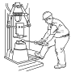 | - Working with the back bent forward more than 30° (without support or the ability to vary posture) | More than 4 hours total per day
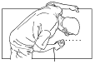 | - Working with the back bent forward more than 45° (without support or the ability to vary posture) | More than 2 hours total per day
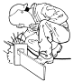 | - Squatting | More than 4 hours total per day

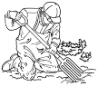 | - Kneeling | More than 4 hours total per day
HIGH HAND FORCE |  | HAZARD EXISTS |  | COMMENTS/OBSERVATIONS

Pinching an unsupported object(s) weighing 2 lbs or more per hand, or pinching with a force of 4 lbs or more per hand (comparable to pinching a half a ream of paper)
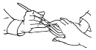 | - Highly Repetitive Motion | More than 3 hours total per day
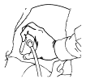 | 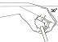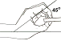  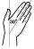 | More than 3 hours total per day
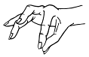 | - No other risk factors | More than 4 hours total per day
Gripping an unsupported object(s) weighing 10 lbs or more per hand, or gripping with a force of 10 lbs or more per hand (comparable to clamping light duty automotive jumper cables onto a battery)
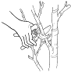 | - Highly Repetitive Motion | More than 3 hours total per day
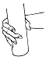 |  | More than 3 hours total per day

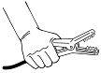 | - No other risk factors | More than 4 hours total per day
HIGHLY REPETITIVE MOTION |  | HAZARD EXISTS |  |  | COMMENTS/OBSERVATIONS
Using the same motion with little or no variation every few seconds (excluding keying activities)
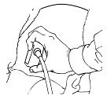 | - 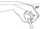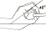  High, forceful exertions with the hand(s) | More than 2 hours total per day
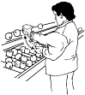 | - No other risk factors | More than 6 hours total per day
Intensive keying
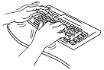 |  |  | More than 4 hours total per day
 | - No other risk factors |  | More than 7 hours total per day

REPEATED IMPACT |  | HAZARD EXISTS |  | COMMENTS/OBSERVATIONS
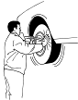 | - Using the hand (heel/base of palm) as a hammer more than once per minute | More than 2 hours total per day
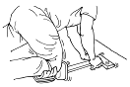 | - Using the knee as a hammer more than once per minute | More than 2 hours total per day

APPENDIX D | CALCULATOR FOR ANALYZING LIFTING OPERATIONS

How many lifts  per minute? | How many hours per day?
How many lifts  per minute? | 1 hr or less | 1 hr to 2 hrs | 2 hrs or more
1 lift every 2-5 min | 1.0 | 0.95 | 0.85
1 lift every min | 0.95 | 0.9 | 0.75
2-3 lifts every min | 0.9 | 0.85 | 0.65
4-5 lifts every min | 0.85 | 0.7 | 0.45
6-7 lifts every min | 0.75 | 0.5 | 0.25
8-9 lifts every min | 0.6 | 0.35 | 0.15
10+ lifts every min | 0.3 | 0.2 | 0.0
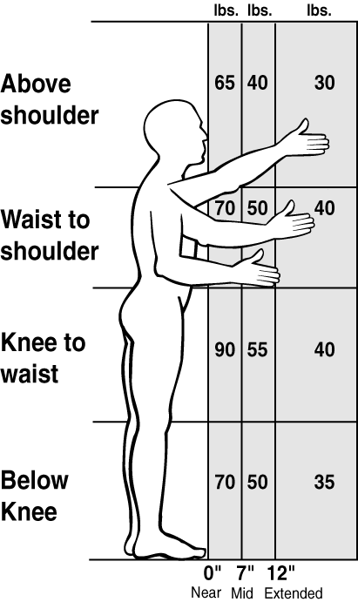
1.0
0.85
- Circle 0.85 if the person twists 45 degrees or more while lifting, otherwise circle 1.0
- Circle the number that corresponds to the times the person lifts per minute and the total number of hours per day spent lifting. Note: For lifting done less than once every five minutes, use 1.0
Date
- Circle the number on a rectangle below that corresponds to the position of the person’s hands when they begin to lift or lower the objects.

Weight Lifted
lbs.
- Enter the weight of the object lifted.
Job
Evaluator

 |  |  |  |  |  |  | Lifting Limit
lb. |  | X |  | X |  | = |  | lb.
Step  2 |  |  | Step  3 |  | Step  4
HANDS POSITION (2)  - Reduce the horizontal distance from the body  - Remove barriers, obstacles  - Reduce weight of load  - Reduce capacity of the container  - Team lift the object with two or more workers  - Design workstations with adjustable heights to eliminate forward trunk bend  - Provide handholds  - Store objects at 30 inches off the floor | FREQUENCY (3)  - Increase weight of a load so it requires mechanical assistance  - Improve layout to minimize manual material handling  - Use mobile storage racks
DURATION (3)  - Use mechanical assistance such as overhead hoist, manipulator, vacuum lift, pneumatic balancer, or forklift  - Eliminate the use of deep shelves  - Job rotation to other jobs where no lifting is required | TWISTING (4)  - Redesign workstation layout to eliminate trunk twisting  - Locate lifting operations in front of the body  - Use slides, gravity, chutes to eliminate lifting/twisting
- SOLUTIONS PRINCIPLES
To find the most appropriate solution for this job, look for the lowest number you used when calculating (2, 3, 4)
- Is the Weight Lifted less than the lifting Limit?
Yes - OK; No - Re-design
- Copy below the numbers you’ve circled in steps 2, 3, and 4.
Yes – OK
No – HAZARD
See back for solution ideas.

APPENDIX E | CALCULATOR FOR HAND-ARM VIBRATION
Vibration

m/s2

- Find the vibration value for the tool. Get it from the manufacturer.
On the graph below, mark the point on the left side shown as Vibration value.

- Find out how many total hours per day the employee is using the tool and mark
Duration

Hrs.
that point on the bottom of the chart below.

- Trace a line onto the graph from each of these two points until they cross.
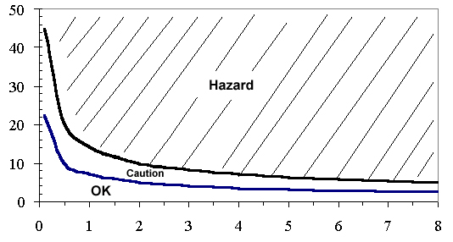


- 5 -

- Interpretation
  - If that point lies in the crosshatched “Hazard” area above the upper curve, then the vibration hazard must be reduced below the hazard level, or to the degree technologically and economically feasible.
  - If the point lies between the two curves in the “Caution” area, then the job remains as a “Caution Zone Job.”
  - If the point falls in the “OK” area below the bottom curve, then no further steps are required.

Note: The caution limit curve (bottom) is based on an 8-hour energy-equivalent frequency- weighted acceleration value of 2.5 m/s2. The hazard limit curve (top) is based on an 8-hour energy-equivalent frequency- weighted acceleration value of 5 m/s2.

